2022 SANDWICH CHRISTMAS IN THE VILLAGE APPLICATION
December 3rd & December 4th, 2022
Started over 40 years ago by an enterprising group of local craftspeople, Sandwich Christmas in the Village has grown into a two-day holiday tradition, expanding and reinventing itself with each new generation.

What will it be like this year?
Like last year, there will only be smaller physical venues - open studios, small shops and outside spaces, along with virtual participants selling from their own websites, all with coordinated information on the Christmas in the Village website and Facebook page.

How would this work?
This event’s success relies on you. It will be up to you, as individual crafters, to decide if you want to have your own location, or share one with others in Sandwich; OR if you have your own website/social media page to just participate "virtually" OR both. In any case, doing your own marketing thru social media will be critical in expanding to expand our reach to potential customers.

Aside from the website, group marketing will on social media promotion, with press releases and calendar listings, but no paid advertising. Participant listings, maps and directions will be available on the website as viewable pages and as documents to download and print. The large menu board signs will be set up on Route 25 and the large red stockings will be available to hang outside any physical location as usual.

AND because we are keeping it simple, there will be no cost to the participants again this year, because most of our budget in the past has gone towards printing, paid ads, signs and banners, and the wagon rides between the major venues. Our main expense this year will be upgrading and hosting for the website
Who can participate?
- Local craftspeople, artisans, authors, farmers, food providers, businesses and related holiday and entertainment providers
- Physical locations will be limited to Sandwich and its immediate adjacent area
- Virtual only participants can include:
  - Anyone who has participated in Xmas in the Village in the past few years
  - The only new participants eligible in 2022 are folks from Sandwich, and surrounding towns: Tamworth, Moultonborough, Center Harbor, Holderness.
What is required of participants?
- Complete the entry form AND remit suitable photos for the website and other marketing by November 5, 2022. Listings will be added to the website as they come in. NO listings will be added without complete data, photos or other appropriate artwork.
- Market the show through your social media and by word of mouth
- If you are selling at a physical location, PLEASE STAY OPEN FOR THE HOURS YOU ADVERTISE, except if weather makes travel prohibitive. Notify us re: changes ASAP so we can update the website & Facebook.
- Please respond to customer inquiries and on-line orders as promptly as you can, especially you are a virtual participant only.
QUESTIONS? Call or text Julie Deak at 603-707-0140
Or visit our website: sandwichchristmasinthevillage.com

2022 CHRISTMAS IN THE VILLAGE APPLICATION Date __________________
Please fill out this form, and scan or take a photo of it, along with at least one photo, and
Send to: sandwichchristmasinthevillage@gmail.com BY NOVEMBER 5, 2022
If you have questions or need more information, contact Julie Deak at 603-707-0140 or juliedeak.nh@gmail.com
===========================================================================================================Contact Information
Contact Name _______________________________________________________
Business Name ______________________________________________________
Address__________________________________________________________________________________
Mailing Address, if different_________________________________________________________________
Email Address ___________________________________________Telephone Number _________________
Website and/or other online addresses ( e.g. Facebook)________________________________________________

Can customers make purchases at your webpage? YES / NO
=========================================================================================
Listing Information - This info will used on the CIV website, Facebook page and in other marketing.
Business Name____________________________________________________________________________
Description items/services featured at CIV:_____________________________________________________
_________________________________________________________________________________________
_________________________________________________________________________________________
(SEE NEXT PAGE FOR SAMPLE LISTINGS)
=========================================================================================If you will be open at a physical location:
Address:___________________________________________________________________________
Dates and Times you’ll be open:________________________________________________________
Your listing will include a link to your on-line address as above to get more information
=========================================================================================
If you will be only a “virtual” participant:
How would you like customers to contact you for more information? Check all that apply.
Link to my website/other online address_________ Email___________ Call___________
If you select “Email” and/or “Call “ in this section, your email address and/or phone # may be displayed in your CIV listing, otherwise customers will find your contact info thru your webpage.
======================================================================================== IF YOU WOULD LIKE TO BE INVOLVED IN PLANNING/ OVERALL MARKETING FOR THE EVENT, PLEASE CHECK HERE _____
SAMPLE LISTINGS
Physical Location Virtual Participant Virtual Participant
Online shopping ONLY No website, call or email ONLY
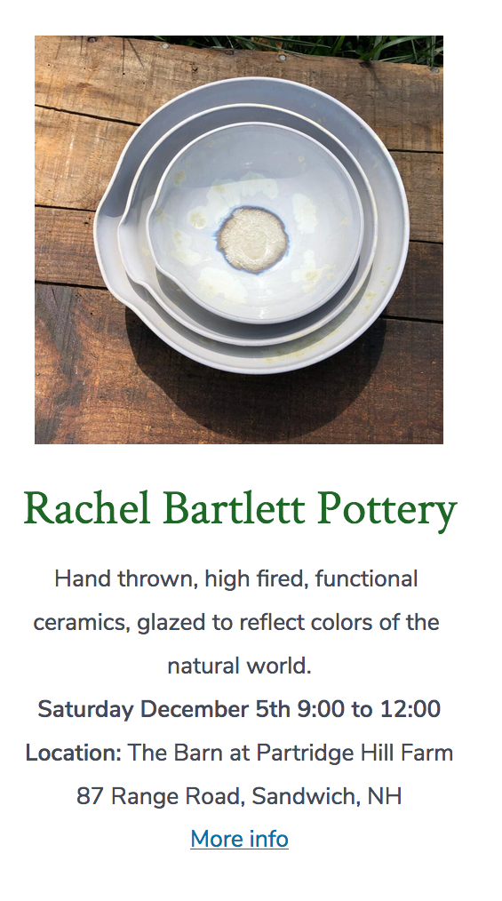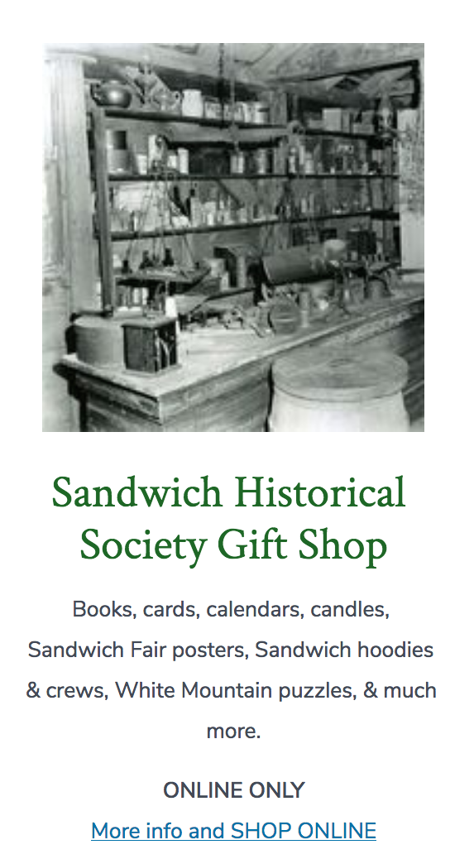

Note: These are samples only.
Format and content may change when the listing page goes live.

